Sample Project Approach (Roadmap)

Title
Machine Learning-Based Consumer Purchase Behavior Analytics

Domain
Business Analytics | Machine Learning | Customer Analytics | Data Science

Dataset
I recommend using three benchmark datasets together:

- UCI Online Retail II Dataset
  - Customer transactions from a UK-based online retail store.
  - https://archive.ics.uci.edu/ml/datasets/Online+Retail+II

- Kaggle Customer Personality Analysis Dataset
  - Customer demographics, spending habits, campaign responses, purchases.
  - https://www.kaggle.com/datasets/imakash3011/customer-personality-analysis

- World Bank Group E-Commerce Customer Behavior Dataset
  - Online shopping behavior, browsing activity, purchase history.
https://datacatalog.worldbank.org/search/dataset/0048927/malawi-integrated-household-living-conditions-survey-2010-2011-subset-for-machine-learning-comparative-assessment-project

Abstract:

The project "Machine Learning-Based Consumer Purchase Behavior Analytics" aims to analyze customer purchasing behavior using machine learning and data analytics techniques. It combines benchmark datasets containing customer transactions, demographics, spending patterns, and online shopping behavior to understand how customers make purchasing decisions. The project follows a complete data science pipeline, including data cleaning, exploratory data analysis (EDA), feature engineering, machine learning model development, explainable AI, and dashboard visualization. Multiple machine learning models such as Logistic Regression, Decision Tree, Random Forest, XGBoost, and CatBoost are compared to identify the most accurate model for predicting customer purchases, customer churn, and customer lifetime value. Finally, an interactive Streamlit dashboard is developed to provide business insights that help organizations improve customer engagement, marketing strategies, and sales performance.

Data Analytics (EDA)
EDA Flow

Raw Dataset
↓
Dataset Overview
↓
Data Quality Assessment
↓
Descriptive Statistics
↓
Missing Values Analysis
↓
Duplicate Records
↓
Outlier Detection
↓
Customer Demographics Analysis
↓
Purchase Pattern Analysis
↓
Product Category Analysis
↓
Customer Segmentation
↓
RFM Analysis
↓
Correlation Analysis
↓
Feature Engineering
↓
Feature Selection
↓
Machine Learning Models

Include 12–15 analytical techniques for deeper business insights.

Preprocessing
- Missing Value Handling
- Duplicate Removal
- Data Cleaning
- Encoding Categorical Variables
- Feature Scaling
- Outlier Detection
- Date-Time Feature Extraction
- RFM Feature Engineering
- Feature Selection

Machine Learning Models
- Logistic Regression
- Decision Tree
- Random Forest
- XGBoost
- CatBoost
- LightGBM (Optional)

Customer Analytics
- Purchase Prediction
- Customer Segmentation
- Customer Lifetime Value Prediction
- Purchase Frequency Prediction
- Customer Churn Prediction
- Product Recommendation

Explainable AI
- SHAP
- LIME

Visualization
- Heatmap
- Boxplot
- Correlation Matrix
- Customer Segmentation Charts
- Sales Dashboard
- Product Category Analysis
- Purchase Trend Analysis
- Feature Importance Plot
- Customer Lifetime Value Dashboard
- Interactive Streamlit Dashboard

Comparative Analysis
Compare:
- Logistic Regression
- Decision Tree
- Random Forest
- XGBoost
- CatBoost

Metrics:
Accuracy Precision Recall
F1-Score ROC-AUC
Confusion Matrix

Recommended Research Pipeline
Benchmark Datasets
↓
Data Cleaning
↓
Exploratory Data Analysis (EDA)
↓
Feature Engineering
↓
Feature Selection
↓
Train-Test Split
↓
Machine Learning Models
(Logistic Regression, Decision Tree, Random Forest, XGBoost, CatBoost)
↓
Performance Evaluation
↓
Explainable AI (SHAP + LIME)
↓
Interactive Business Intelligence Dashboard (Streamlit)
↓
Comparative Analysis
↓
Customer Purchase Prediction & Customer Segmentation
↓
Research Conclusions

Expected Project Outcome
- Analyze customer demographics and purchasing behavior.
- Predict future customer purchases using machine learning.
- Identify customer segments using data-driven techniques.
- Predict customer churn and customer lifetime value.
- Explain model predictions using SHAP and LIME.
- Develop an interactive Streamlit dashboard for business decision support.
- Compare multiple machine learning models and identify the best-performing approach.
- Generate actionable business insights to improve customer engagement and sales.

Architecture Diagram

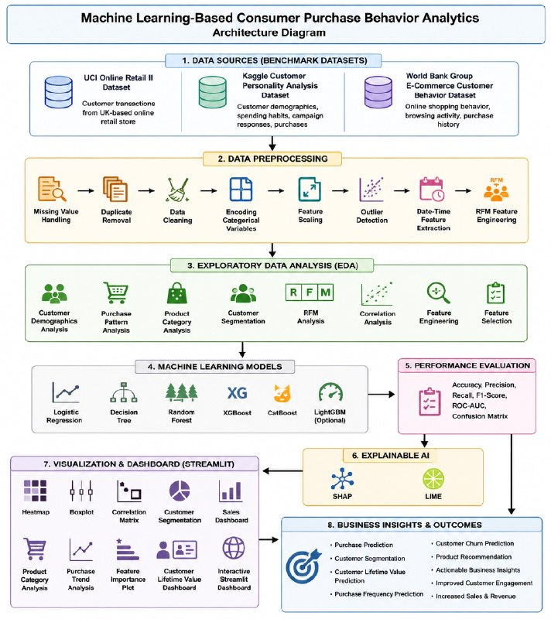
Names:
2420030373-M.Pallavi
2420030481-G.Divija Medha
2420090067-Sheri Saswitha

